Vijay Super Mall App – PRD
Oct 10, 2026 · @Mahipal

1. Overview, goals and roles
Vijay Super Mall's app lets customers shop the store's full range like any e-commerce app, then take free home delivery or pick up in store. The owner runs inventory, hot sales, orders, coupons and coin earning rules from one admin panel.
Store context (from the stall card): Vijay Super Mall, phone 97140 00027. Categories: Kariyanu (Grocery), Gruh Udyog (Home Industry), Dry Fruit, Cosmetic, Ice-cream & Cold Drink. Promise: Free Home Delivery. The app keeps the card's maroon, red and gold look, the cart logo, and Gujarati plus English labels.

Goals
- Customers can browse, search, add to cart, pay and track an order from their phone.
- The admin can update stock, prices and Hot Sale items without a developer.
- The admin can move each order through Packed, Ready for Pickup and Delivered, and the customer is notified at each step.
- Every purchase earns coins; the admin sets how many coins a purchase earns (spend X, get Y); customers redeem coins on later purchases.
- The store can exclude chosen items from coin redemption and issue coupon codes.

Roles
Role | What they do
Customer | Browses, orders, pays, earns and redeems coins, applies coupons, tracks orders
Admin (owner) | Full control: inventory, hot sale, orders, coin rules, coupons, reports
Staff (optional) | Sees orders and updates status only; no pricing or coin settings

Success measures (proposed, to agree)
- Share of orders placed through the app vs phone and walk-in
- Repeat-purchase rate among customers who hold coins
- Time from order placed to Ready for Pickup or Out for Delivery
- Share of orders that use a coupon or coins

2. Customer app
The customer app covers the full path from sign-in to a delivered order, the same flow people know from any grocery or e-commerce app.
- Sign-in: phone number and OTP, name and delivery address on first login. Language toggle: Gujarati / English.
- Home: search bar, banner carousel, Hot Sale strip, the five category tiles from the stall card, coin balance chip, and "Free Home Delivery" badge.
- Browse and search: category and sub-category lists, product grid, filters (price, brand, in stock), sort, and search by name in Gujarati or English.
- Product page: photos, name, unit and price, MRP with discount, stock state, quantity stepper, coins earned on this item, and a clear note when coins cannot be used on it.
- Cart: edit quantities, apply a coupon code, choose how many coins to use (full balance, a percentage, or a typed amount), see the bill breakup.
- Checkout: choose Home Delivery (free) or Store Pickup, address or pickup slot, payment (UPI, card, cash on delivery or pay at pickup), and place the order.
- Orders: live status timeline, order detail, reorder, cancel while still Placed, and support call button to 97140 00027.
- Wallet: coin balance, earn and spend history, expiry dates, and the current earning rule (for example, spend ₹1,000, get 10 coins).
- Profile: addresses, language, notifications, and help.

3. Admin panel
The admin panel runs as a mobile-friendly web dashboard (and inside the same app for the owner's login), so the owner can manage the shop from the counter or from a phone.

Inventory
- Add, edit and archive products with Gujarati and English names, category, unit, price, MRP, photos, and barcode.
- Set stock quantity, low-stock alert level, and a per-product Available toggle; out-of-stock items show as unavailable.
- Bulk update by CSV upload (price and stock) for large catalogues.
- Coin controls per product: "Earns coins" toggle and "Allow coin redemption" toggle. When redemption is off, the app never lets coins reduce that item's price.
- Mark a product as Hot Sale with a sale price and optional start and end date.

Hot Sale and banners
- Hot Sale strip on Home is built from products marked Hot Sale and sorted by the admin.
- Banners for festivals and offers, with image, link target (category, product or coupon) and schedule.

Orders
- Order list with filters (status, date, delivery or pickup), search by order number or phone.
- Order detail with items, address, payment state and a one-tap status update (see section 4).
- Print or share a packing slip; call or WhatsApp the customer.

Rewards and coupons
- Coin rules: earn rate, expiry, redemption cap and the earning rules (spend X, get Y coins) (section 5).
- Coupon builder and usage report (section 6).

Reports
- Daily sales, top products, low stock, coins issued vs redeemed, coupon usage.

4. Order lifecycle
Every order moves through fixed statuses that only the admin or staff can advance. The customer sees the same status live and gets a notification at each step.
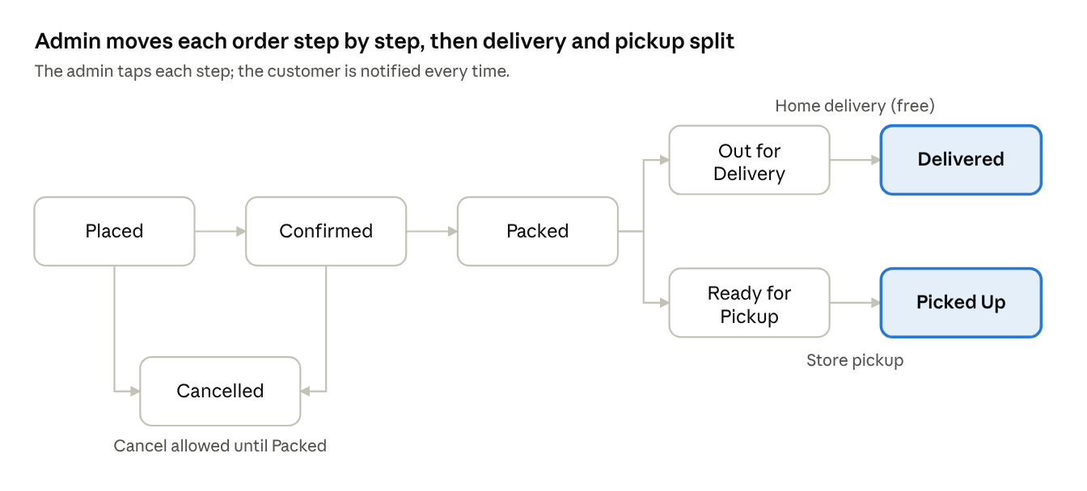
order status flow · delivery and pickup branches
After Packed the order follows one of two lanes, depending on what the customer chose at checkout.
Status | Set by | Customer sees | Rules
Placed | Customer | Order received | Customer can cancel
Confirmed | Admin | Store accepted your order | Stock is reserved
Packed | Admin | Your order is packed | Cancellation closes
Ready for Pickup | Admin | Ready, show your order number at the counter | Pickup orders only; admin sets a hold time
Out for Delivery | Admin | On the way, with delivery person's phone if added | Delivery orders only
Delivered or Picked Up | Admin | Thank you, coins credited | Coins are credited, order closes
Cancelled | Customer or admin | Reason shown | Coins and any prepaid amount are returned

5. Coins, redemption and earning rules
Coins reward repeat buying. They are earned on purchases, spent on later purchases. Starting values below are defaults the admin can change.

Earning
- Default rule: 10 coins for every ₹1,000 of eligible purchase, set by the admin as "spend X, get Y coins" (pro-rata or in whole slabs, admin's choice).
- Coins are credited when the order is Delivered or Picked Up, not when it is placed. A cancelled or returned order reverses its coins.
- A product can be set to "Earns coins: off" in inventory.

Redeeming
- 1 coin = ₹1 of discount (default, admin-editable).
- At cart, the customer picks Use all coins, Use a percentage (25, 50, 75 or a typed x%), or Use a number of coins.
- Coins can only reduce the price of items where "Allow coin redemption" is on. Excluded items show a small "No coins" tag in the cart.
- The usable amount is the smallest of: chosen coins; the eligible items' subtotal; and the admin's per-order cap (default: 100% of eligible subtotal, editable).
- Coins are applied before delivery charges and taxes; the bill shows coins used on its own line.
- Unused coins stay in the wallet. Coins expire after a period the admin sets (default: 12 months, oldest first).

Earning rules (admin-configured)
- The admin creates rules in Rewards: name, "spend ₹X, get Y coins" (for example spend ₹1,000, get 10 coins), mode, scope (all items or chosen categories), start and end date, and an active switch.
- Mode is either pro-rata (₹2,500 earns 25 coins at 10 per ₹1,000) or slab (₹2,500 earns 20 coins, because only two full ₹1,000 slabs were reached).
- When more than one rule applies to an order, the one that gives the most coins is used; rules do not stack.
- A rule change affects new orders only. Each order records which rule it used and how many coins it earned.
- The admin screen shows a live preview, such as "a ₹2,500 order earns 25 coins".
- Coins come only from purchases under these rules. There is no lucky draw. The admin can also add or remove coins by hand with a required reason, and each change is logged.

Rules that avoid disputes
Situation | Behaviour
Coupon and coins together | Allowed by default; the coupon is applied first, coins apply to what is left of eligible items
Item on Hot Sale | Coin redemption follows the product's own toggle
Partial refund | Coins used on refunded items go back to the wallet
Order cancelled after coins applied | All used coins returned
Staff role | Cannot edit coin rules

6. Coupons, notifications and payments

Coupons
The admin creates coupon codes in a simple form; customers apply them in the cart.
Field | Notes
Code and description | For example a festival code; case-insensitive
Type | Flat ₹ off, or % off with a maximum discount
Minimum cart value | Optional
Applies to | All items, selected categories, or selected products
Validity | Start and end date
Limits | Total uses and uses per customer; first-order-only option
Works with coins | Yes by default; can be switched off per coupon
- The cart shows a clear error for an invalid, expired or ineligible code, and says why.
- The admin sees usage count and total discount given per coupon.

Notifications
- Push notification (and optional SMS or WhatsApp) when an order is Confirmed, Packed, Ready for Pickup, Out for Delivery and Delivered.
- Alerts for coins earned, coins about to expire, new earning offers and new Hot Sale items.
- Admin gets an alert for a new order and for low stock.

Payments
- Online: UPI and cards through a payment gateway; Cash on Delivery for home delivery; Pay at Store for pickup.
- Prepaid orders cancelled before packing are refunded to the original method.

7. Data, screens, requirements, phases and open questions

Core data
Entity | Key fields
User | phone, name, language, role, addresses
Product | names (GU, EN), category, unit, price, MRP, stock, available, earns_coins, allow_coin_redemption, hot_sale, sale_price, sale dates
Order | number, user, items, delivery or pickup, address or slot, status, payment state, coupon, coins_used, coins_earned
Coin ledger | user, order, type (earn, spend, reverse, expire, adjustment), coins, expiry date
Coupon | code, type, value, min cart, scope, validity, limits, works_with_coins
Earning rule | name, spend amount X, coins Y, mode (pro-rata or slab), scope, start and end date, active

Screens to design (see the Figma file)
- Customer: Login, Home, Category list, Product list, Product detail, Cart with coins and coupon, Checkout, Order tracking, Orders, Wallet, Profile.
- Admin: Dashboard, Orders list, Order detail with status update, Inventory list, Product edit with coin toggles, Hot Sale manager, Coupons, Coin earning rules, Reports.

Non-functional
- Gujarati and English throughout, with Gujarati-capable fonts in all screens.
- Runs on Android first, iOS next; admin on phone and desktop browser.
- Order and coin updates must be transactional so a coin is never spent twice.
- Admin actions that change money (coin rules, earning rules, refunds) are logged with user and time.
- Works on slow networks: cached catalogue, small images.

Phases
- MVP: login, catalogue, cart, checkout with cash on delivery and pay at store, order status updates, inventory, Hot Sale.
- Rewards: coins earn and redeem, per-item exclusion, coupons, online payments.
- Engagement: festive coin offers, banners, reports, WhatsApp notifications.

Open questions
- Should coins be pro-rata or slab-based by default? This PRD lets the admin choose per rule and defaults to pro-rata.
- Is 1 coin = ₹1 right, and what is the per-order cap on coin use?
- Delivery area, delivery time slots, and whether any minimum order applies to free delivery.
- Which payment gateway, and does the store need GST invoices?
- Should one login serve both customer and admin, or should the admin use a separate app or web page?

